Handling input virtual controllers
Raúl Matías Contreras Morán
- Use cases
 | 
On the mobile phones the virtual inputs controllers are being very useful for creating a fitted keyboard to the user while in the computer are usefull for the known hoods
- Steps for creating a virtual controller
- Is necessary to get a skin atlas before make nothing, this can be managed with Skin Composer
- Next we have to create a stage, and set it as the current input controller
- Finally, we have to set up the hud of the screen currently running
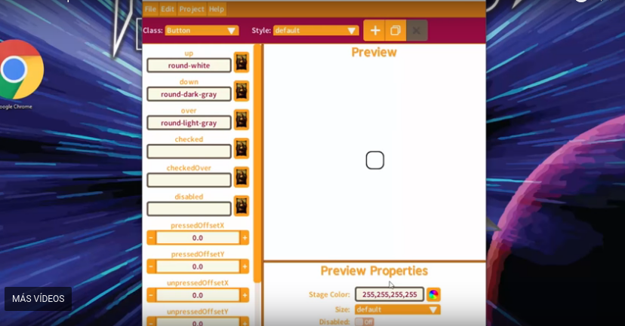
- Get started
Is necessary first to enumerate the classes we are going to use:
- Stage: this class turn us able to use it as the input controller, and we will use the addActor method for adding widgets to the screen
- Skin: is the class that wraps the skin files, the resulting object will be used to create buttons, labels, etc…
- Actor classes: this type of classes have an addListener method wich we will pass a clickListener instance in wich we will can handle the application current state, some of them are: buttons, labels, tables, etc...
- get implemented (stage class)
private Stage stage;

public void create () {
stage = new Stage(new ScreenViewport());
Gdx.input.setInputProcessor(stage);
}

public void resize (int width, int height) {
// See below for what true means.
stage.getViewport().update(width, height, true);
}

public void render (float delta) {
Gdx.gl.glClear(GL20.GL_COLOR_BUFFER_BIT);
stage.act(delta);
addButton();
addTable();
stage.draw();
}

public void dispose() {
stage.dispose();
}
- GET IMPLmented (TextButton)
Skin skin = new Skin(Gdx.files.getFileHandle(“data/uiskin.json”, FileTypes.Internal));

public void addButton() {

TextButton tb = new TextButton("Text on the Button", skin);

tb.setPosition(200, 200); // set a position
tb.setSize(100, 50); // set size

stage.addActor(tb); // add to the scene

}
- Get implemented (table)
public void addTable() {

Label nameLabel = new Label("Name:", skin);
TextField nameText = new TextField("", skin);
Label addressLabel = new Label("Address:", skin);
TextField addressText = new TextField("", skin);

Table table = new Table();
table.add(nameLabel);
table.add(nameText).width(100);
table.row();
table.add(addressLabel);
table.add(addressText).width(100);
}

